REL326: The Islamic Path
Professor Steven Daniel Sacks Office: Prall 108
Ebersole 203 MTuW 12:30-3:00 Th 9:00-11:00 F 9:00-12:00

This course will provide a thematic introduction to the major trends within the diverse Islamic tradition. Within the context of a single course, we will strive to introduce a breadth that will allow the student to attain fluency in the language of the tradition, regional and modern trends.

The content and methods in this course correspond to Cornell’s educational priorities:
- Knowledge: Students will integrate and apply knowledge from an interdisciplinary perspective in order to understand Islam.
- Inquiry: Students will encounter a variety of interpretive schema, and will be asked to produce critical analysis to discern the benefits and detriments of differing interpretations and positions.
- Communication: Students will be asked to develop skills in oral presentation and argumentation in every class session and in formal written assignments, and to provide clear structured arguments, with ample use of source materials, on written assignments.
- Intercultural Literacy: Students will be asked to identify with, argue on behalf of, and critique a wide variety of perspectives and positions with which they do not personally identify.
- Ethical Behavior: The study of the history and interpretation of Islam is an ethical endeavor.

Grading:
Class participation and leadership 20%
Film Essays (3) 15%
Paper + Presentation (1) 35%
Exam (1) 30%

All readings are listed below, due on the day that they appear, and may be downloaded from our Moodle forum. You are expected to bring your readings to class every day.
Our textbooks are:
Denny, F.M. An Introduction to Islam (4th Edition) ISBN: 013814477X
Qur’an ISBN: 9780199535958

I will hold regular office hours before class 10:00-11:00 MTuW, but please feel free to contact me at any time if you have questions or concerns about the course. The present schedule and/or readings are liable to be amended as is necessary. Students are expected to complete a significant amount of work outside of the course which supplements scheduled hours within the classroom, and exceeds the government’s regulations on course credit equivalency.

Cornell College expects all members of the Cornell community to act with academic integrity. An important aspect of academic integrity is respecting the work of others. A student is expected to explicitly acknowledge ideas, claims, observations, or data of others, unless generally known. When a piece of work is submitted for credit, a student is asserting that the submission is her or his work unless there is a citation of a specific source. If there is no appropriate acknowledgement of sources, whether intended or not, this may constitute a violation of the College’s requirement for honesty in academic work and may be treated as a case of academic dishonesty. The procedures regarding how the College deals with cases of academic dishonesty appear in The Catalogue, under the heading “Academic Honesty.”
Students who need accommodations for learning disabilities must provide documentation from a professional qualified to diagnose learning disabilities. For more information see cornellcollege.edu/disabilities/documentation/index.shtml
In order to prepare for each class, you will be required to do the following:

- Marginalia: Print out every reading, and every time you feel the urge to highlight or underline something, write out in the margins why you wanted to underline it. Why is that passage important? Is it a major new point in the argument? A significant piece of support? A summary of the opposition? A particularly strong or particularly weak point? Use the margins to summarize the text, ask questions, give assent and protest vehemently – do not just color the pages. You will scan and electronically submit your marginalia on Fridays.
- Leadership: Every day one member of the class will assume the role of leader, outlining the principal argument and premises of each major reading, and composing additional questions of argument or rationale addressed to our readings.
- Film Essays: In this assignment, focus on an image, a piece of dialogue, a scene, a character or any element of the films that we will view, and to develop a short essay response. Reflect upon the significance of artistic or documentary representations of Islam within the context of the readings and discussions that we have in our course. What is the purpose of this film? What is the director’s overarching understanding of Islam? How? Why? Each essay should be a minimum of 250 words, and will be due within three class sessions after each film has been viewed.

Rubrics
Class Participation:
The grade for class participation will be categorized as follows: “A” for exceptional contributions to our daily discussions and the Moodle forum, with no missing or late assignments. “A-“ for exceptional contributions, with one missing or late assignment; “B+” for excellent and consistent contributions to our daily discussions and the Moodle forum; “B” for solid contributions to our daily discussions or Moodle forum, with one or two missing or late assignments; “B-” for uneven contributions to our daily discussion or the Moodle forum; C+ for uneven contributions to our daily discussion and the Moodle forum, with two or three missing or late assignments; “C” and below for poor effort to participate in our daily discussions and the moodle forum, with three or more missing or late assignments.

Papers:
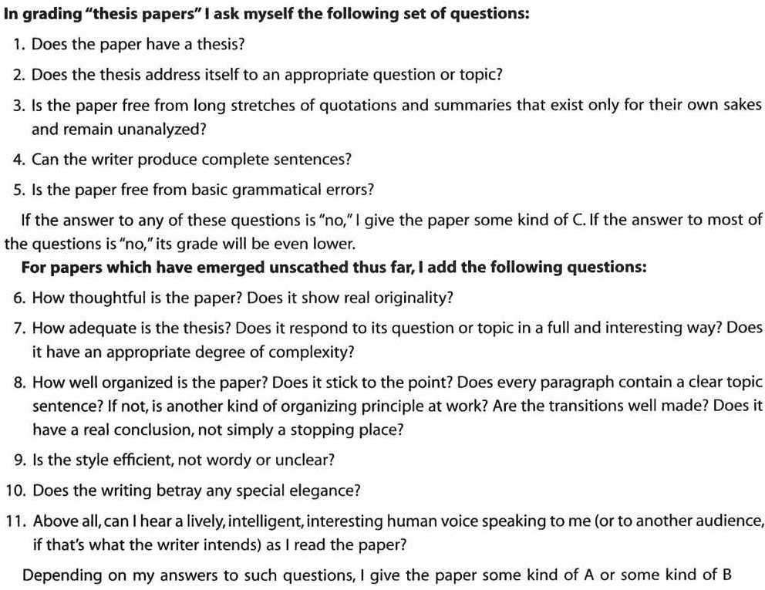

Schedule
Monday, November 26:
Introduction, description of course and goals
Denny, chapter five.

Tuesday, November 27: Idolatry and the Arabian Peninsula Prior to Islam
Denny, chapter two.
Ibn Al-Kalbi The Book of Idols

Wednesday, November 28: Muhammad and the Revelation of the Qur’an
Denny, chapter three.
Hoyland, R. “History, fiction and authorship in the first centuries of Islam” 16-46.
Crone and Cook, Hagarism vii-viii, 73-82 and 139-148.
**See Charts in Hodgson (Week Two)**

Thursday, November 29: The Qur’an
Denny, chapter six and seven.
Esack The Quran: A User’s Guide 30-99

Friday, November 30:
FILM: The Message (1976) – Cole 108

Monday, December 3: Hadith and Fiqh
Denny, chapter nine.
Hodgson, M. The Venture of Islam 315-358.
Kamali Principles of Islamic Jurisprudence 12-21.

Tuesday, December 4: Shi’ism
Daftary, The Ismailis 34-86.
Ayoub Redemptive Suffering in Islam 15-19, 23-25 and 54-68.
** PAPER MEETINGS**

Wednesday, December 5: Islamic Philosophy
Denny, chapter eight
Ibn Tufayl Hayy Ibn Yaqzan
Alfarabi The Political Regime 31-57.

Thursday, December 6: Sufism
Denny, chapters ten and eleven.
Corbin, H. Alone with the Alone 179-245.

Friday, December 7:
FILM: Persepolis (2007) – Cole 108

Monday, December 10: Orientalism and Political Islam
Denny, chapter fourteen.
Said, Orientalism 1-28.
Ayatollah Khomeini Islam and Revolution 286-294.

Tuesday, December 11: Cultural Differences in Islam
Geertz, Islam Observed 1-55.
Qutb Signposts Along the Road 136-144.
** PAPER MEETINGS**

Wednesday, December 12: Global Islam
Roy, O. Islam and Resistance in Afghanistan xi-53.
Roy, O. Globalized Islam (Selections)
Islamic State Dabiq

Thursday, December 13: Islam Onward
Menoret Joyriding in Riyadh 1-20.
Rudnyckyj Spiritual Economies 1-24.

Friday, December 14:
FILM: The Battle of Algiers (1966)/ Timbuktu (2014) – Cole 108

Monday, December 17:
Presentations/Review

Tuesday, December 18:
EXAM

Wednesday, December 19:
** Paper Due**

